Document Analysis (1)
Source Booklet

Source 1: Giving Rope – a British cartoon published in Punch magazine in February, 1919.

German Criminal (to allied police): “Here, I say, Stop! You’re hurting me!”
Says to himself – “If I only whine enough I may be able to wriggle out of this yet!”

Source 2: German Foreign Minister, Count Brockdorff-Rantzau who headed the German delegation to the Paris Peace Conference in 1919.

“Gentlemen, we are deeply impressed with the great mission that has brought us here to give to the world forthwith a lasting peace….We know the intensity of the hatred which meets us, and we have heard the victors passionate demand that as the vanquished we shall be made to pay, and as the guilty we will be punished.

The demand is made that we shall acknowledge that we alone are guilty of having caused the war. Such a confession in my mouth would be a lie. We are far from seeking to escape from any responsibility for the world war, and for its having been waged as it has…… but we with all emphasis deny that the people of Germany, who were convinced that they were waging a war of defence, should be burdened with the sole guilt of that war….”

Source 3: Cartoonist David Low, 1921 The Star newspaper. (British)
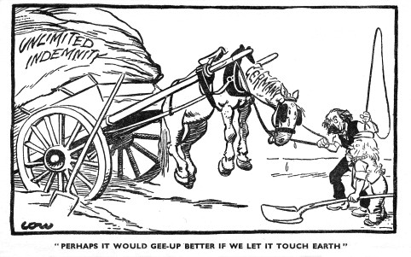

Clemenceau

Lloyd-George

Source 4: Uphill Struggle – poster produced by the German Democratic Party for the elections in 1924.

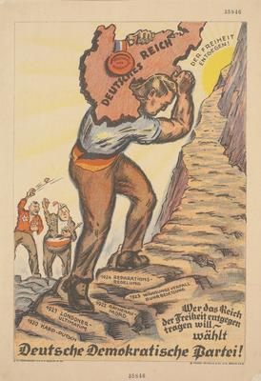

On towards freedom

The steps
show key
events, eg
1920 Kapp,
Treaty of
Versailles,
Murder of
Rathenau,
1923 -
Reparations
forfeit.

Who will carry the Reich to freedom – choose the DDP

Source 5: Extracts from Gustav Stresseman’s speech on being awarded the Nobel Peace Prize
in 1926. (edited)

If one seeks to analyze experiences and reactions to the first post-war years, I hope one may say without being accused of bias that it is easier for the victor than for the vanquished to advocate peace. For the victor, peace means the preservation of the position of power which he has secured. For the vanquished, it means resigning himself to the position left to him. ……

This was the problem facing the new Germany…..

The courtesy which most becomes a victor was denied to Germany for a long time. Germany had to assume super-human reparations which the people would never have borne had there not existed an ageless legacy of service to the state. Historians still often see the end of the war as meaning nothing more for Germany than lost territories, lost participation in colonization, and lost assets for the state and individuals. They frequently overlook the most serious loss that Germany suffered. This was, in my view, the intellectual and professional middle class, which traditionally upheld the idea of service to the state, paid for its total devotion to the state during the war with the total loss of its
own wealth, …… . Its money became worthless when the state, which had issued it, refused to redeem it at face value…..

But all that has taken place in Germany since the war must be looked at in the light of the mood of this completely uprooted class. ….. They all had shared in the rise and fall of Germany's fortunes during the war, but not one had expected this disaster.

….. A people that has experienced all that the Germans have been through, naturally offers fertile soil for the extremists. The ballast in the center of the German ship which saved it from heavy rolling in the past, that valuable and steady middle class group, no longer exists. The uprooted saw their hope in a complete reversal of affairs. It was at this time that the great tide of Bolshevism broke over Germany, appearing on the left as Communism and on the right as National Socialism. That a nation, whose currency had collapsed, whose social and economic reorganization had been as ruthless as ours - that this nation, which had to learn to live in an entirely new situation, has been able to master Bolshevism of the Right and of the Left, shows the healthiness of its spirit, the zeal of its industriousness, and the victory of realpolitik* over the imaginary and illusory.

* realpolitik - a system of politics or principles based on practical rather than moral or ideological considerations, based on a country's situation and its needs rather than on ideas.

End of Sources

